Designing Test Cases in Robot Framework
Using RIDE
V1.2
March 14, 2014

The purpose of this document is to explain to users how to design test cases in Robot Framework using its IDE, RIDE.

This document explains how to run your first test on Robot Framework with the Selenium2Library and the RIDE IDE. Although this document uses web testing as an example, the concepts apply to other types of systems under test.

Pre-Requisites
- Install Robot Framework, Python, and several related projects on your machine. Refer to the document “Robot Framework for Windows Installation Instructions.”
- Install Firefox.

Writing the First Test Case

Following are the initial steps to building a test case

- Using Windows Explorer, create a directory, which will be the name of the project.
  - The project name in the example is “My Project”.
  - At this time, just create the project directory. Later in this example, the directory structure will be:

Project name: My Project

Set of Test Suites: TestCases

Test Suite: My First suite

Test: Google Search

- Using Windows Explorer, create one or more directories inside the project folder for the test suites. In the example the test suites will be saved in the directory “TestCases”.
- Now perform the RIDE Import of the project by using the menu command “File → Open Directory”, and choosing the project directory that contains the directory of test suites. This is the directory “My Project” in our example. Selecting the menu item looks like this:

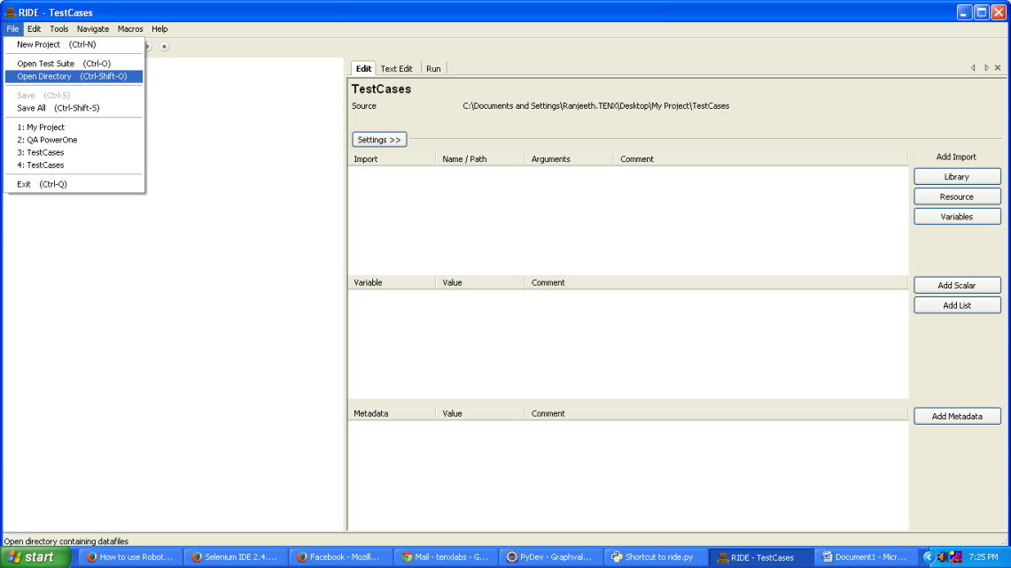

Select the “My Project” directory in the “Browse For Folder” pop-up window. As a result, the directory tree structure in RIDE will look like this:

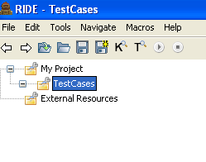
- Create a new test suite: right click on TestCases and choose New Suite. Give the test suite a name, such as “My First suite”

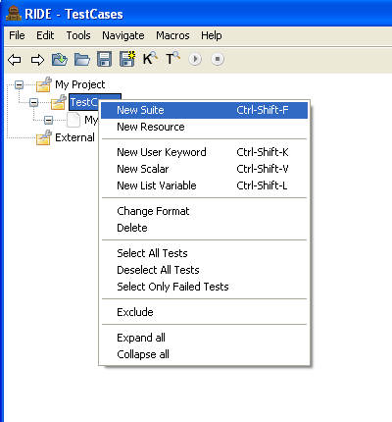

- Right click on the test suite to create a new test case. Give the name of the test case. In the example the name is “Google Search”. (The example does not contain the complete test case, but the test case could be enhanced to perform a Google search.)
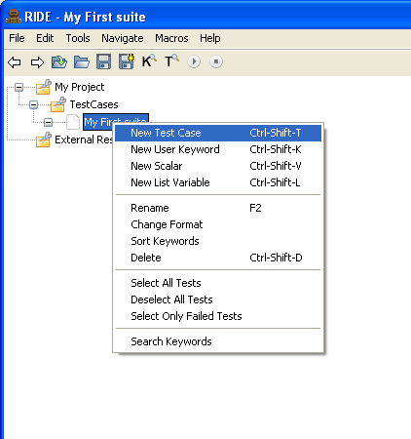
- In order to use Selenium2Library key words we have to import theSelenium2 library. Click on the test cases directory and in the Settings section click on “Library” at the right. Then enter the library name as shown below.

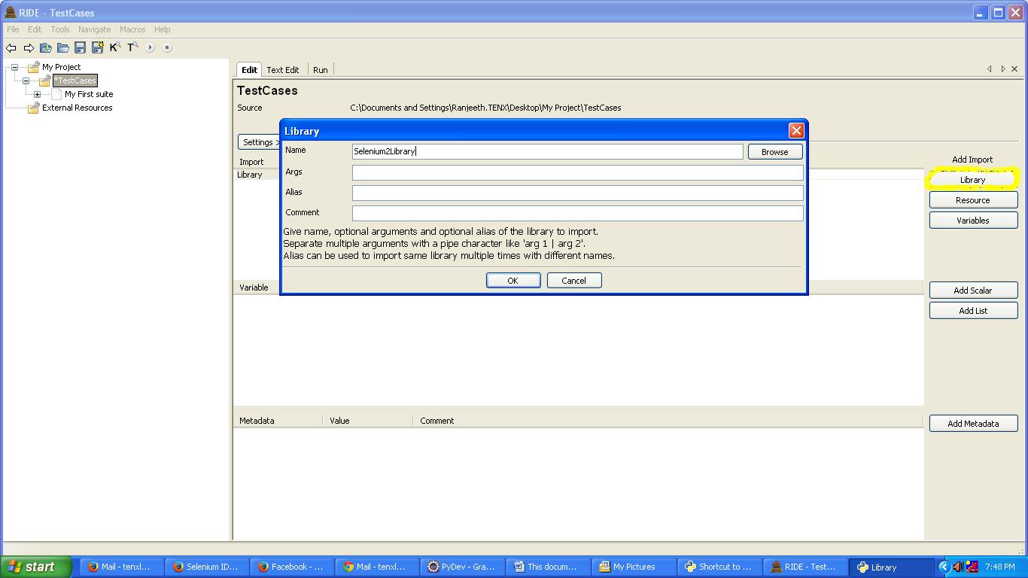

Now that we have imported the Selenium2Library we are able to access the keywords that are part of the Selenium2Library.
The test case consists of a set of keywords and parameters, as well as supporting resources (including scalar values) and libraries. If you select a test case and the “Edit” tab, you can enter the keywords and parameters in the RIDE grid.
If you select a test case and enter the first few characters of a keyword as one of the keywords to be executed as part of the test, Ctrl + Space gives all the matching keywords, as can be seen below:

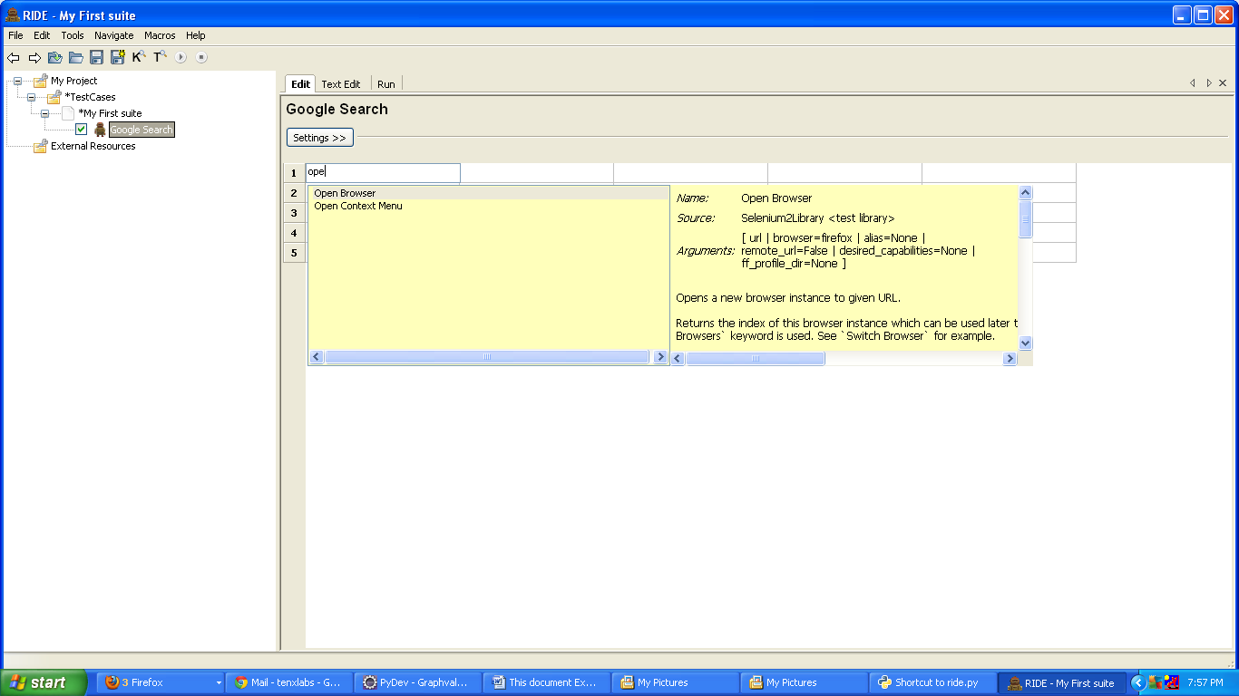
The example test case will open a browser. So enter the following keyword and two parameters:
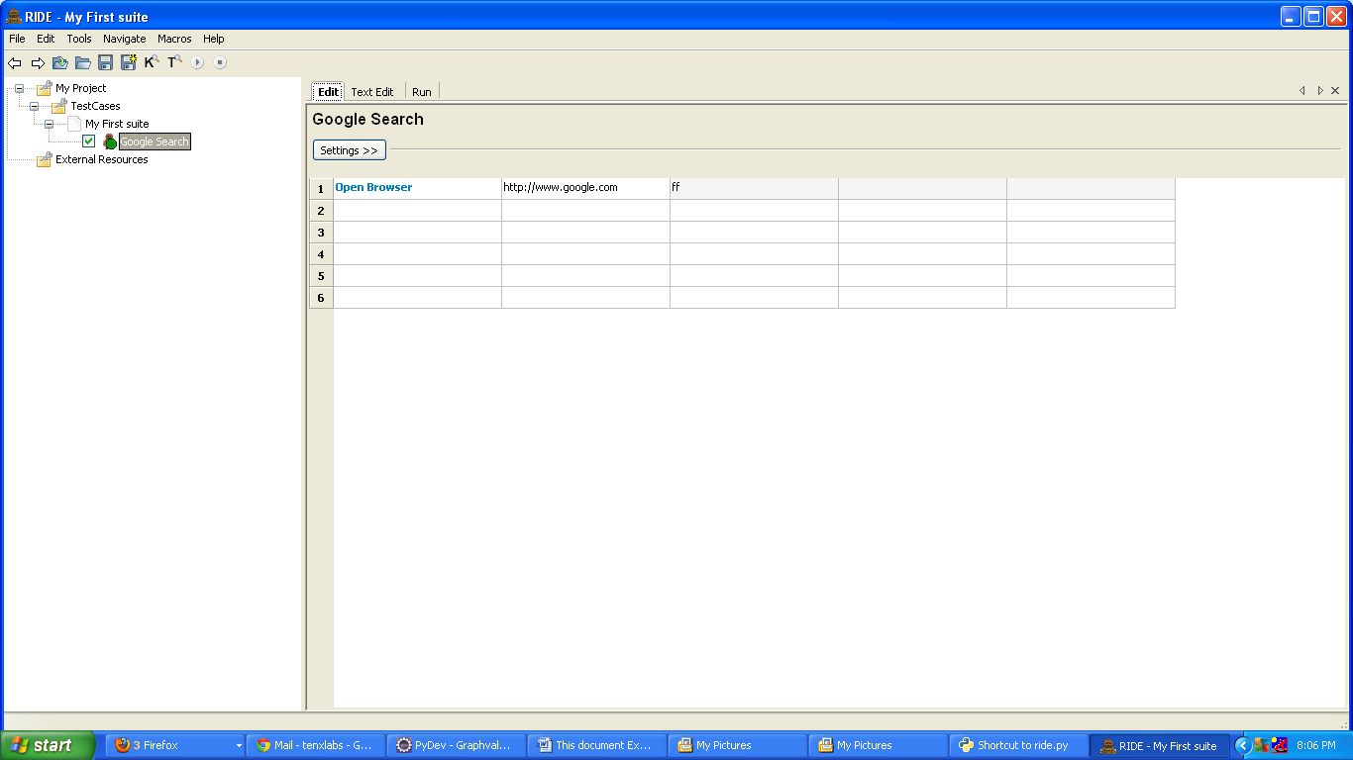
“Open Browser” is a keyword. Keywords from the Selenium2Library or keywords that are in the Robot Framework “BuiltIn” library are available.
Click on the Run tab and then click on Start to run the test. The result can be seen on the Run tab
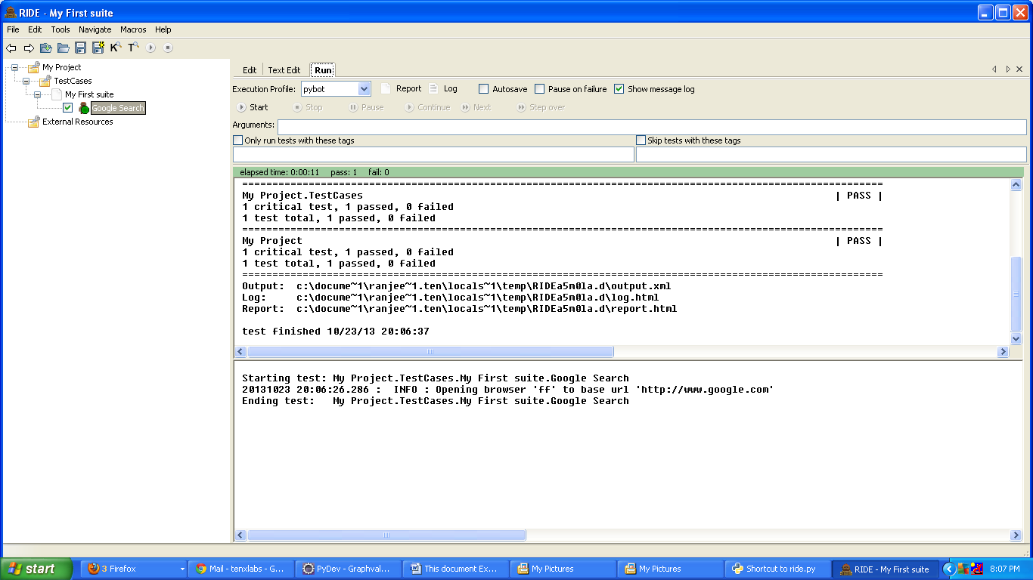

To see the log file click on the Log button. Otherwise copy the below address and open the log in a browser.
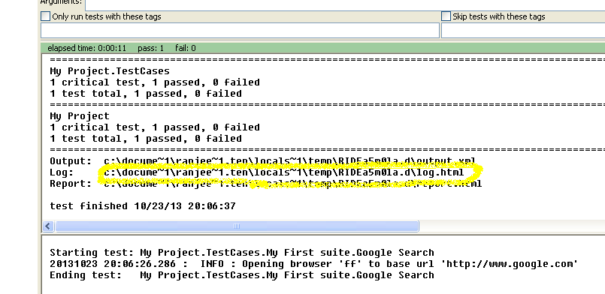

Now that a basic test case was built, we can define and use our own scalar values and keywords.
Following the Keyword structure:
First close RIDE. Using Windows explorer, create a directory with the name Keywords in the project folder. Start RIDE again, and again use Open Directory to open the “My Project” directory.
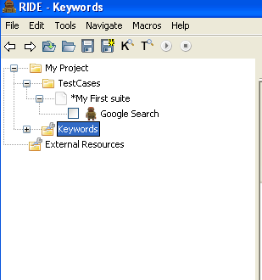
Right-click on Keywords→New Resource. This command is used to add a file containing resources.
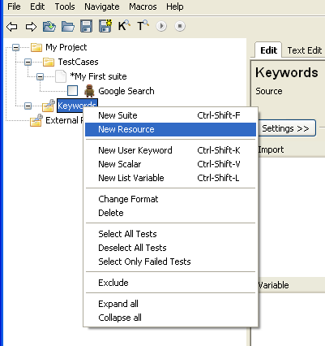

Add the name of a file, such as global.txt. Then to add a scalar, right click on the file name and choose New Scalar. Name the resource and add a scalar value as shown.
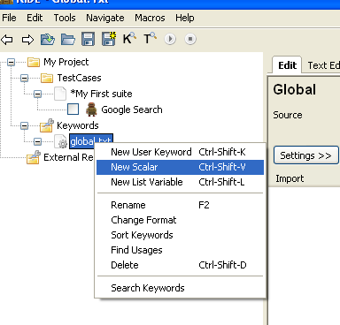
Give the scalar name as specified, using the syntax “${scalar_name}”.
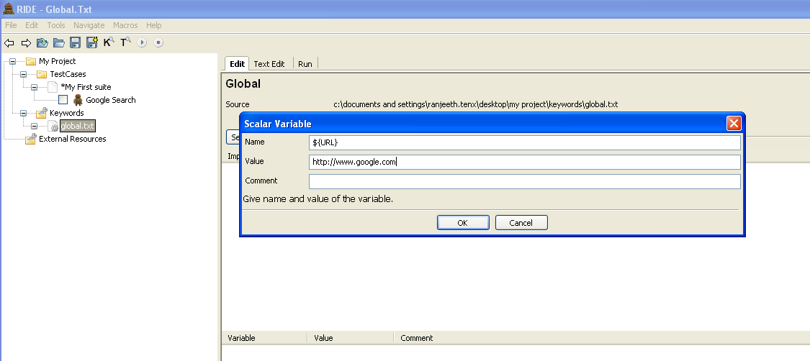
Now we are going to import this resource library and use the new scalar. Click on “Resource” and fill in the filename. Note that relative to the tests, the global.txt file is at “../Keywords/global.txt”. Use regular slashes, not the backslash.

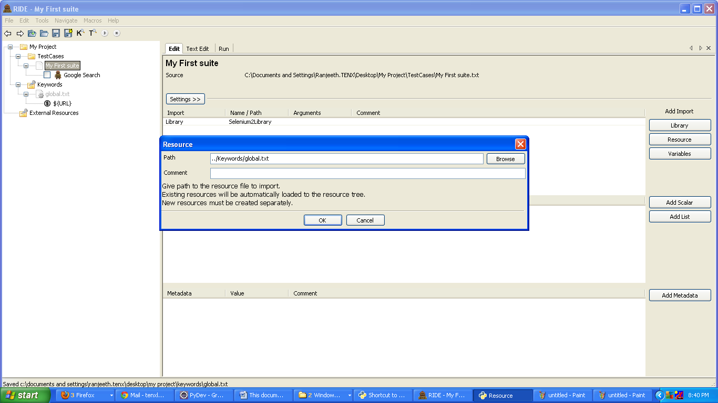
Now we can use the scalar in our test case as shown below
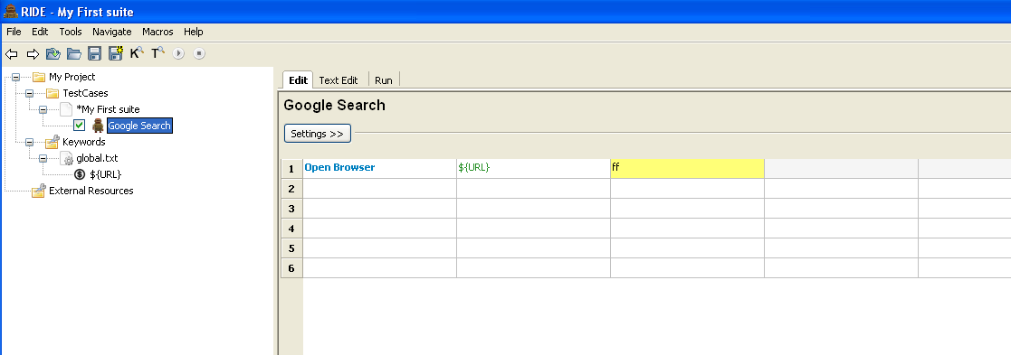

Adding Object Resources
Again close RIDE. Using Windows explorer, create a directory with the name Objects in the project folder. Start RIDE again, and again use Open Directory to open the “My Project” directory.
To add a resource to Objects, right click on Objects and choose New Resource.
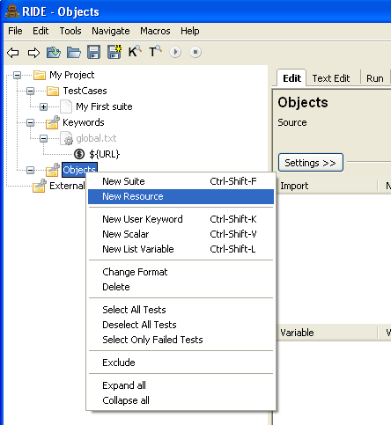
Enter the name of a file that will contain a set of resources. If you enter “home” a file called “home.txt” will be added to hold resources.
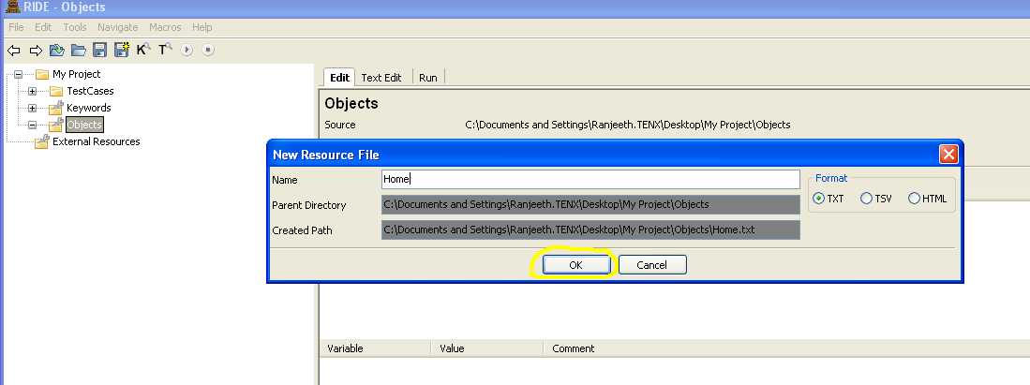

To add a scalar variable that represents an object to a particular file, such as “home.txt”, right click on home.txt and choose New Scalar.
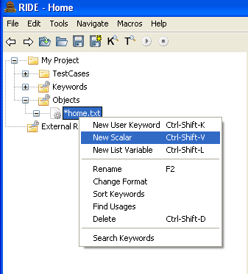
Give a specific name for the scalar as shown in the image below.
The name can indicate the type of the object and the application page where the object appears. The value is the “locator” used by Selenium2 to find the object on the page.
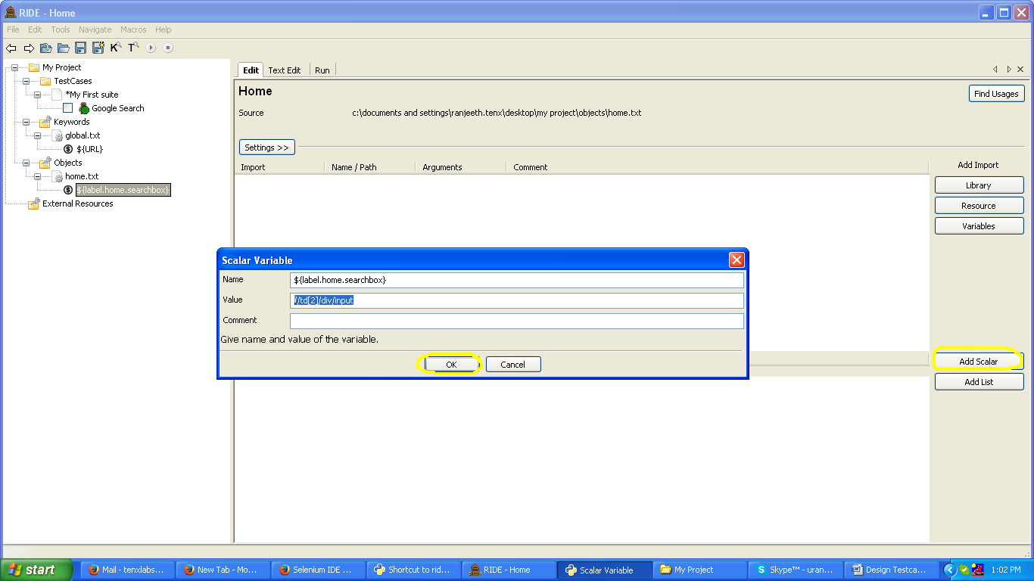

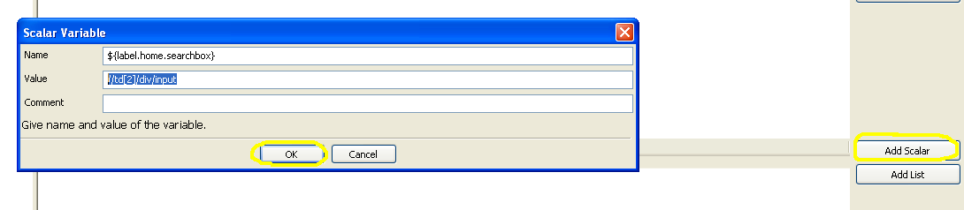
In order to access this scalar variable in our test case we need to import its file as another resource.
Importing the home.txt in the Objects directory:
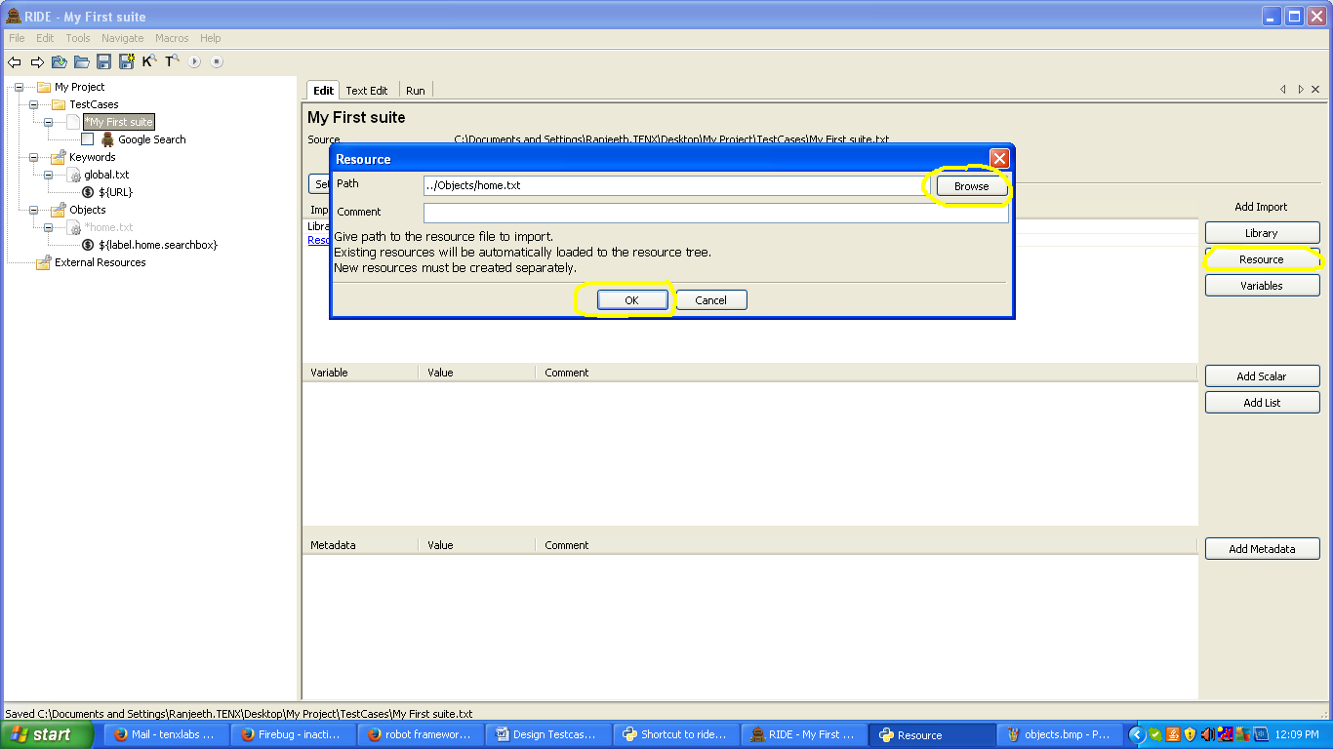
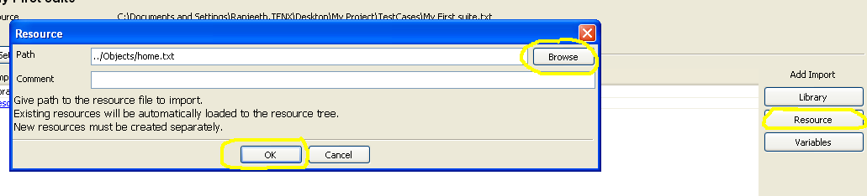
Note that the home.txt resource file is located at “../Objects/home.txt”. The “current directory” when the test runs is the one that contains the test cases (the TestCases directory in this example). The two dots navigate up one directory, to My Project. And “../Objects” navigates to the Objects directory.
Now we are able to use the saved objects in our sample test case.
An object could be a locator to an element on a web page. You can use Firebug or Developer tools from Chrome or Internet Explorer to get information about the element you want to manipulate in the test. If you use Chrome Developer tools and right click on the web element, you can get a copy of the xpath to the element. You can then use the xpath as the “value” of the new object – its locator. Fill in the object name and give the xpath as the value.
See Selenium documentation for other ways to define locators, such as by ID or element name.
Optionally, object names for elements on a page can follow this syntax: ${<object type>.<page where used>.<object description>}.

Run the test case to be sure there are no errors
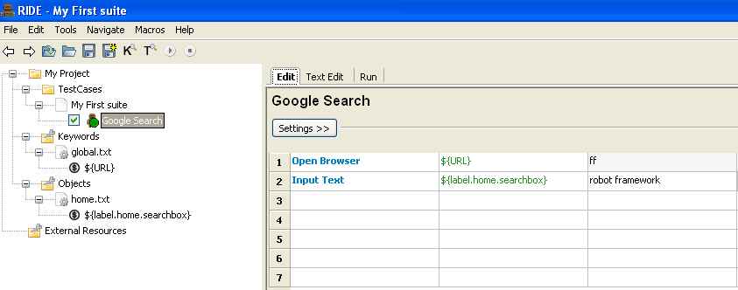

Create and Import Custom Library methods
I have created a sample Python file where we can define the methods and use them in our test case as shown.
Below is the code that I wrote and saved as a .py file
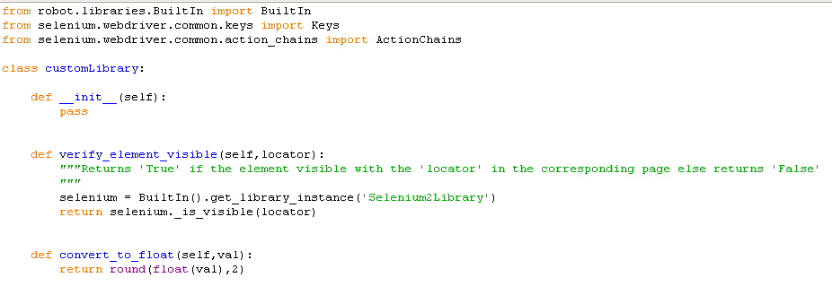
Import the file to make the following keywords available
1. verify_element_visible
2. convert_to_float
To import the file, click on “Library” at the right and add the file as a library file as shown
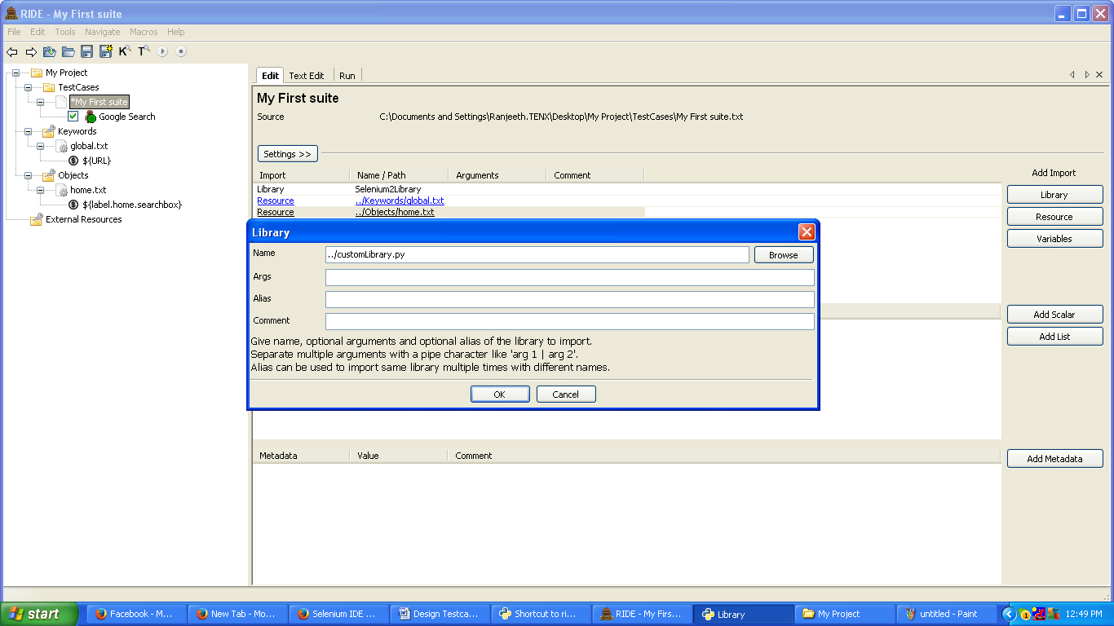
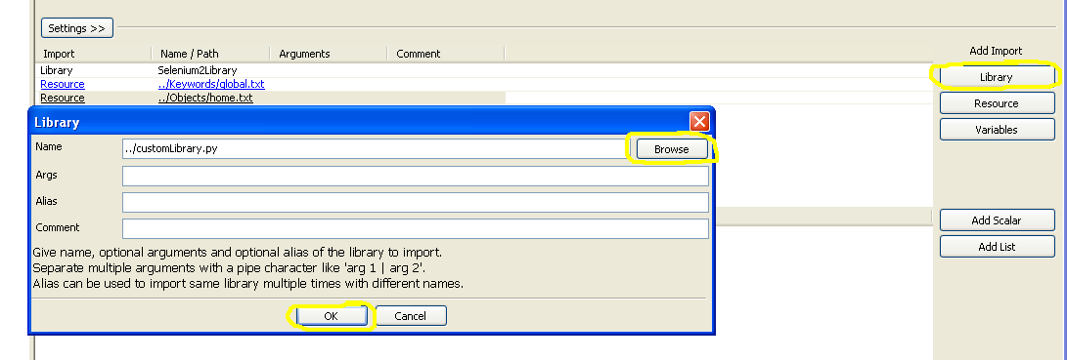
Note that the file is listed as “../customLibrary.py”, so the customLibrary.py file in this case is located in the parent directory of the directory with the test cases. An alternate approach would be to create a “Libraries” directory in My Projects when you create the Keywords directory, and put the libraries in that folder. In this case, the name used would then be “../Libraries/customLibrary.py.
Alternatively, a file with a name such as “ResourcesAndLibraries.txt” could be built that lists several resources and libraries. If that file were in the Keywords directory, then the file could be added as a resource and its location would be ../Keywords/ResourcesAndLibraries.txt.
The ResourcesAndLibraries.txt file should contain the word “Library” or “Resource” in the first part of a row, and the location of the Library or Resource after some space. In addition, a library that was installed as part of the Python installation could be named. If the Library or Resource file is given using a relative file name, the directory should be relative to the directory with the test cases. The directory need not be listed for a library that was installed as part of the Python installation. An example of a file that adds several libraries and resources follows:
*** Settings ***
Library Selenium2Library
Library ../Library/customLibrary.py
Library Collections
Library String
Library OperatingSystem
Resource ../Keywords/global.txt
Resource ../Keywords/commonKW.txt
Resource ../Keywords/home.txt
Resource ../Keywords/orders.txt
Resource ../Keywords/assetsKW.txt
Resource ../Keywords/footer.txt
Resource ../Keywords/reportsKW.txt
Resource ../Objects/assets.txt
Resource ../Objects/common.txt
Resource ../Objects/footer.txt
Resource ../Objects/home.txt
Resource ../Objects/summary.txt
Resource ../Objects/reports.txt

Now we can use the keywords defined in the customLibrary in our test case as shown
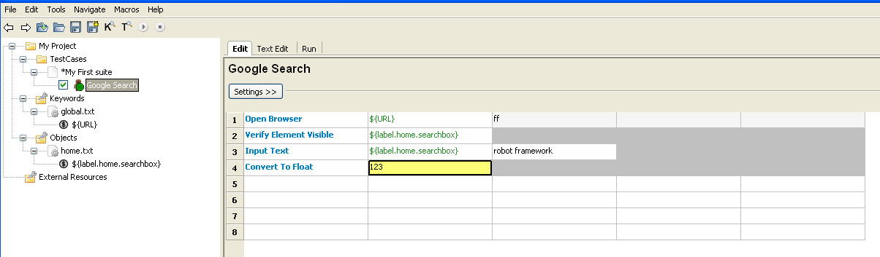
Run the test case by choosing the Run tab and clicking on Start.
You can also add your own keywords in the Keywords section, and these new keywords could be built from other keywords and parameters. In this case, you fill out the steps for the new keyword (the keywords it calls and their parameters) in the grid within RIDE, just as you did when you were building the test case.
Your test case now has access to
- keywords defined by the Selenium2Library
- keywords defined as Robot Framework “built-ins”
- keywords defined by Python libraries
- keywords built as methods using Python in a custom library Python file
- keywords you build out of other keywords and their parameters
- resources used as parameters to keywords
- objects, such as locators to elements on a web page, used as parameters to keywords
RIDE and RobotFramework also support control statements to modify program flow, such as a FOR loop. See Robot Framework documentation for further information.

